EMBLEM SPECIFICATIONS
Structure
- Reinforced concrete, according to the drawings, concrete code design and anti-earthquake
design rules and regulations
- Lowest concrete strength C37.
- The Iron used is an EU product category B500C, approved by the government and designed according to Eurocode standards.
Insulation
- External walls 25cm thermal type bricks – Main skeleton externally insulated with 8cm polystyrene
- All houses, exposed roofs and all verandas on top of internal spaces will be
insulated with high quality water proofing material and polystyrene for thermal insulation,
all to Site Inspector`s approval
- The entire structure will be thermally insulated to meet the requirements
of the Energy Performance Department of the Ministry of Commerce, Industry and Tourism of Cyprus
- Energy Performance Certificate will be issued (Energy efficient A).
Wall Finishes
- Interior: 3 coats of plaster plus 2 coats of spatula plus 3 coats of emulsion
- Exterior: 2 coats of acrylic plaster with mesh and finishing with acrylic grafiato.
Kitchen
- Modern design kitchen with clean lines, open spaces and highly functional made from MDF wood and lacquered glossy finish.
- Worktop in Granite
Floors
- High quality European ceramic tiles size 90cm x 90cm or 60cm x 120cm in perfect marble finish or Laminate Parque.
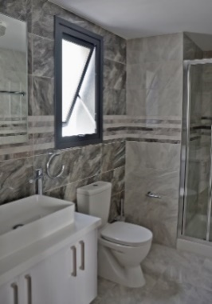
Bathroom Finishes
- High quality European ceramic tiles in marble finish - Quality vanity units
- Vanity unit top surface from marble or granite
- High quality sanitary ware, accessories and mixers (GROHE & EUROGROHE & VILLEROY BOCH)

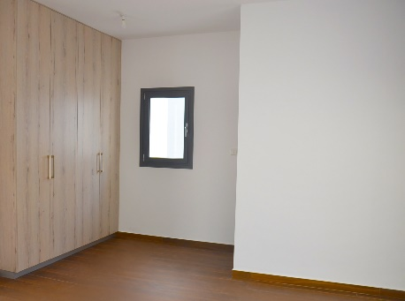
Wardrobes
- All wardrobes with hinged doors. Made of MDF maximum height 2.80m.
- Wardrobes are manufactured in Cyprus by a local carpentry factory for better maintenance
Electrical – Mechanical
- All electrical works will be carried out according to the latest edition of the IEE
regulations and according to the electrical layout of all floors
in bedrooms and in living/dining areas. Latest recognized brands
- Connection to sewerage system
- Water pressure System – Solar heater
- Complete installation of central structure cabling system for TV, telephone and computer throughout the house
- Water proof sockets in verandas
- Intercom with camera
- Provision for underfloor heating

Air-condition Units
- VRV for cooling (Duct in the living room – wall units in bedrooms)
Falce Ceilings
- As shown in plans
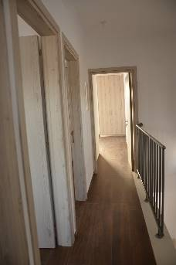
Internal Doors
- All internal doors will be in veneered varnished wood (high pressured laminate) or high gloss finish
- Minimum high 2,42m
- Doors are manufactured in Cyprus by a local carpentry factory for better maintenance
Entrance Door
- Made of high-quality solid wood or alloy (Fireproof)
External Patio Doors and Windows
- All external windows and sliding doors will be in high quality aluminum with thermal insulation and double-glazing energy glass for improved thermal insulation and soundproofing.
Railings
- Railings of verandas will be constructed in special safety glass.
Parking Space
- Covered parking Space No…, with provision for electrical car charger.
- Store No….

Swimming pool– CCTV – Barrier control access – Lobby

