ELYSIAN HOMES SPECIFICATIONS

Structure
- Reinforced concrete, according to the drawings, concrete code design and anti-earthquake
design rules and regulations
- The Iron used is an EU standard, approved by the government and designed according to Eurocode standards
Insulation
- External walls 25cm bricks – Main skeleton externally insulated with 8cm polystyrene
- All houses, exposed roofs and all verandas on top of internal spaces will be
insulated with high quality water proofing material and 8cm polystyrene for thermal insulation,
all to Site Inspector`s approval
- The entire structure will be thermally insulated to meet the requirements of the Energy Performance Department of the Ministry of Commerce, Industry and Tourism of Cyprus
- Energy Performance Certificate will be issued (Energy efficient Α)
Wall Finishes
- Interior: 2 coats of plaster plus 2 coats of spatula plus 3 coats of emulsion
- Exterior: 2 coats of acrylic plaster with mesh and finishing with acrylic grafiato
Kitchen
- Kitchen units and the color scheme of the kitchen set is to be agreed with the customer
- Worktop in granite the color to be agreed with the customer
- MDF and high quality melamine with out handles (GOLA)
Floors
- High quality European ceramic tiles size 60cm x 120cm in perfect marble finish.
- The color scheme is to be agreed with the customer.
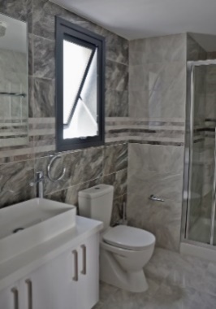
Bathroom Finishes
- High quality European ceramic tiles in marble finish - Quality vanity units
- Vanity unit top surface from marble or granite
- High quality sanitary ware, accessories and mixers (HANSGROHE)
- Wall mounted toilets
- Walk in showers
- The color scheme is to be agreed with the customer
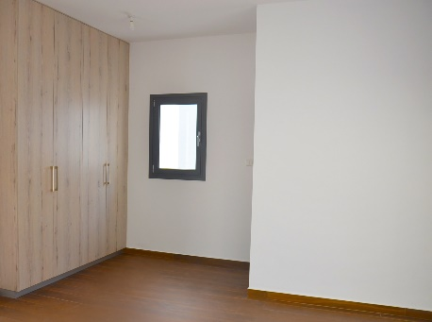
Wardrobes
- All wardrobes with hinged doors, painted in plastic paint or glass fitted doors.
- The color scheme is to be agreed with the customer
Electrical – Mechanical
- All electrical works will be carried out according to the latest edition of the IEE
regulations and according to the electrical layout of all floors
in bedrooms and in living/dining areas. Latest recognized brands
- Solar System
- Water Pressurizing System
- Complete installation of central structure cabling system for TV, telephone and computer throughout the house
- Waterproof sockets in verandas
- Optional shaver socket and hair dryer sockets for all bathrooms
- Provision for a/c units
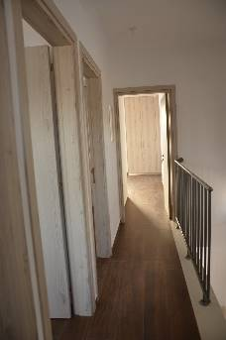
Internal Doors
- All internal doors will be in veneered varnished wood (high pressured laminate) or high gloss paint finish
- The color scheme is to be agreed with the customer
Entrance Door
- Made of high-quality solid or alloy
External Patio Doors and Windows
- All external windows and sliding doors will be in high quality aluminum with thermal insulation and double-glazing energy glass for improved thermal insulation and soundproofing. MU114 MUSKITA SERIES
Railings
- All external veranda and roof garden railings will be constructed in special safety glass
Parking space
- With provision for electrical car charger

