Structure
- Reinforced concrete, according to the drawings, concrete code design and anti-earthquake
design rules and regulations
- Lowest concrete strength C37.
- The Iron used is an EU product category B500C, approved by the government and designed according to Eurocode standards.

Insulation
- External walls 25cm thermal type bricks – Main skeleton externally insulated with 5cm polystyrene
- All houses, exposed roofs and all verandas on top of internal spaces will be
insulated with high quality water proofing material and polystyrene for thermal insulation,
all to Site Inspector`s approval
- The entire structure will be thermally insulated to meet the requirements
of the Energy Performance Department of the Ministry of Commerce, Industry and Tourism of Cyprus
- Energy Performance Certificate will be issued

Wall Finishes
- Interior: 3 coats of plaster plus 2 coats of spatula plus 3 coats of emulsion
- Exterior: 2 coats of acrylic plaster with mesh and finishing with acrylic grafiato.

Kitchen
- Worktop in granite
- High quality units
- Optional kitchen Island bar.
Floors
- High quality European ceramic tiles size 90cm x 90cm or 60cm x 120cm in perfect marble finish or Laminate Parque.
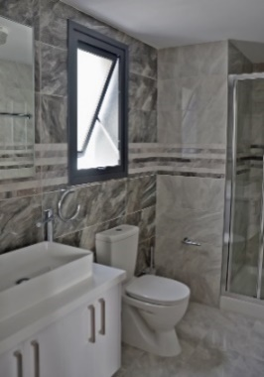
Bathroom Finishes
- High quality European ceramic tiles in marble finish - Quality vanity units
- Vanity unit top surface from marble or granite
- High quality sanitary ware, accessories and mixers (GROHE & EUROGROHE)
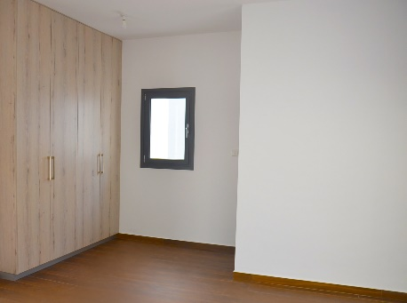
Wardrobes
- All wardrobes with hinged doors, painted in plastic paint or glass fitted doors.
Electrical – Mechanical
- All electrical works will be carried out according to the latest edition of the IEE
regulations and according to the electrical layout of all floors
in bedrooms and in living/dining areas. Latest recognized brands
- Connection to sewerage system
- Solar System, Water Pressurizing System
- Complete installation of central structure cabling system for TV, telephone and computer throughout the house
- Water proof sockets in verandas
- Optional shaver socket and hair dryer sockets to all bathrooms
- WIFI Alarm system.
- Intercom with camera.

Air-condition Units
- VRV type for cooling and heating (Duct – concealed in Kitchen – living area & Wall units in bedrooms)

False ceilings

Underfloor heating
- Underfloor water heating with heat pump for the whole area of the apartment.
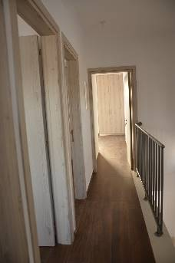
Internal Doors
- All internal doors will be in veneered varnished wood (high pressured laminate) or high gloss finish
Entrance Door
- Made of high-quality solid wood or alloy.
External Patio Doors and Windows
- All external windows and sliding doors will be in high quality aluminum
with thermal insulation and double-glazing energy glass for improved thermal
insulation and soundproofing.

Railings
- All external veranda and roof garden railings will be constructed in special safety glass.

PARKING SPACE
- Parking Space No. P13, with provision for electrical car charger.

Outdoor Jacuzzi – Swimming pool – GYM – CCTV – Barrier control access – Lobby

